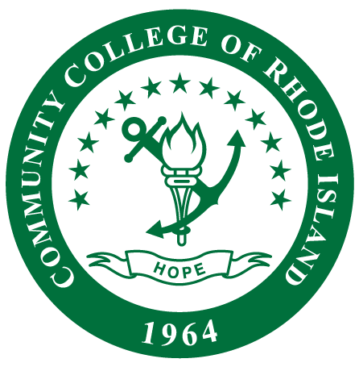
Coming Spring 2024!

New Course: HMNS 8406
Leadership and Reflective
Supervision of Early Childhood Programs
(3 Credits)
Are you a current or upcoming Early Childhood Education Program Leader?
This course will be presented in an online format with in-person meetings held every other Wednesday from 4-6:30 pm at the Knight/Warwick Campus beginning January 24, 2024.
This course will:  - Support credential and career advancement of current or prospective early childhood program leaders  - Provide the development of leadership skills  - Students will explore methods and principles of supervision and leadership in early childcare and education programs. | Emphasis will be placed on:  - Reflective supervision  - Staff hiring  - Onboarding and supervision  - Professional development  - Advocacy  - The leader’s role with curriculum and assessment
Course registration is now available!
Questions? Please Contact Courtney Read at ecread@ccri.edu or Carol Patnaude at cpatnaude@ccri.edu

