Turn your Professional Development and Experience into credits at CCRI!

Did you know that some of your PD trainings and work experience in Early Childhood Education may qualify for Credit for Prior Learning?

CCRI is offering new opportunities for you to earn credit toward your Early Childhood Education certificate and/or associate degree:

- Up to 6 credits for your past professional development trainings
- Up to 6 credits for your Child Development Associate (CDA) credential
- Explore Portfolio Assessment and CLEP opportunities for additional credits!

Whether you’d like to get started with these credits or come back and finish your degree, get the credits you’ve earned!

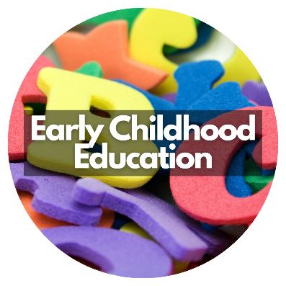

For more information on Credit for Prior Learning at CCRI:

- Please visit www.ccri.edu/priorlearning/ece

- Contact Courtney Read, Associate Professor ECE ecread@ccri.edu, Nicole Sheldon, njsheldon@ccri.edu Prior Learning Coordinator

- Come to our Enrollment Day event at the CCRI Knight campus (Warwick), August 21st 1:00-4:00 pm

