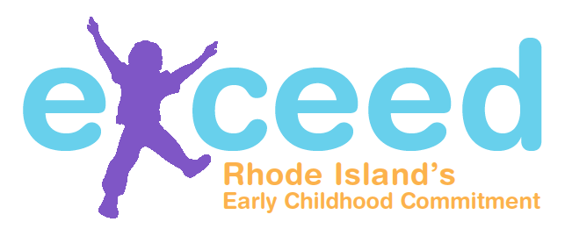
Quality Improvement Plan (QIP)
Goal Sheet

Program: |  | Date:

Goal Number:

Program Goal:

Which set of standards or regulations were used to identify this goal? (Select all that apply.)
DHS Regulations
BrightStars
RIDE: CECE Standards
Head Start
NAEYC
COA – School-Age Accreditation
Other standards or regulations:

What other program information was used to develop this goal?
Examples: DHS monitoring report, BrightStars assessment report, on-site observation, program self-assessment (formal or informal), family survey, classroom observation tools (ERS, CLASS), etc.

What area(s) does this goal address? (Select all that apply.)
Facilities
Health, Safety, and Nutrition
Enrollment and Staffing
Staff Qualifications/Professional Development
Administration
Early Learning and Development: Curriculum
Early Learning and Development: Child Assessment
Family Engagement
Other:

What action steps/strategies will help to achieve this goal? Goal Number:
Action Step/Strategy | Person Responsible | Time Frame | Date Completed

What resources are needed to make progress towards this goal?
Provide detailed descriptions. Examples might include specific materials, technical assistance, professional development, etc.

Progress Notes:
3 Months:

6 Months:

9 Months:

12 Months:

Quality Improvement Plan (QIP)
Goal Sheet

Program: |  | Date:

Goal Number:

Program Goal:

Which set of standards or regulations were used to identify this goal? (Select all that apply.)
DHS Regulations
BrightStars
RIDE: CECE Standards
Head Start
NAEYC
COA – School-Age Accreditation
Other standards or regulations:

What other program information was used to develop this goal?
Examples: DHS monitoring report, BrightStars assessment report, on-site observation, program self-assessment (formal or informal), family survey, classroom observation tools (ERS, CLASS), etc.

What area(s) does this goal address? (Select all that apply.)
Facilities
Health, Safety, and Nutrition
Enrollment and Staffing
Staff Qualifications/Professional Development
Administration
Early Learning and Development: Curriculum
Early Learning and Development: Child Assessment
Family Engagement
Other:

What action steps/strategies will help to achieve this goal? Goal Number:
Action Step/Strategy | Person Responsible | Time Frame | Date Completed

What resources are needed to make progress towards this goal?
Provide detailed descriptions. Examples might include specific materials, technical assistance, professional development, etc.

Progress Notes:
3 Months:

6 Months:

9 Months:

12 Months:

Quality Improvement Plan (QIP)
Goal Sheet

Program: |  | Date:

Goal Number:

Program Goal:

Which set of standards or regulations were used to identify this goal? (Select all that apply.)
DHS Regulations
BrightStars
RIDE: CECE Standards
Head Start
NAEYC
COA – School-Age Accreditation
Other standards or regulations:

What other program information was used to develop this goal?
Examples: DHS monitoring report, BrightStars assessment report, on-site observation, program self-assessment (formal or informal), family survey, classroom observation tools (ERS, CLASS), etc.

What area(s) does this goal address? (Select all that apply.)
Facilities
Health, Safety, and Nutrition
Enrollment and Staffing
Staff Qualifications/Professional Development
Administration
Early Learning and Development: Curriculum
Early Learning and Development: Child Assessment
Family Engagement
Other:

What action steps/strategies will help to achieve this goal? Goal Number:
Action Step/Strategy | Person Responsible | Time Frame | Date Completed

What resources are needed to make progress towards this goal?
Provide detailed descriptions. Examples might include specific materials, technical assistance, professional development, etc.

Progress Notes:
3 Months:

6 Months:

9 Months:

12 Months:

